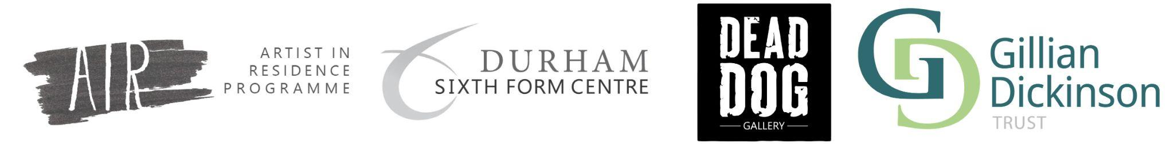

Durham Sixth Form Centre: Artist Residency Proposal - Please ‘Make a copy’

Name:
Phone number:
Email:

Website link:
Instagram/social media links:
Specialism:
Proposed residency length: (Usually 3-6months)
Proposed working days:

Artist Statement (400 words max):

What draws you to taking up a residency in an educational setting? (250 words max)

Which of the following are you interested in:
(Tick all that apply or delete as necessary)
- Community based projects
- Participatory artwork
- Research based practice
- Collaboration with other artists
- Working with young people
- Mentoring / tutoring young people
- The education sector
- Cultural and heritage institutions
- Commercial creative industries
- Social media and marketing
- Other (please outline below)
………………………………………………………………………………………………………………………………………………………………………………...

How did you hear about this residency opportunity?

We are happy to assist artists who identify as having access needs. Please list any requirements below:

Project proposal:
Include a working title, concept of the project, and a project plan with a proposed schedule of activities during your residency (over 3 to 6 months, using the template below). Detail technical requirements (equipment, technical support, etc) that you may need. This could be a continuation of an existing project within your practice or a new concept.

Month 1
Activity:
Notes:
Materials/support needed:

Month 2
Activity:
Notes:
Materials/support needed:

Month 3
Activity:
Notes:
Materials/support needed:

Please add additional months below as required.

Supporting imagery:

